**Online Job Portal**

**Name of the website** – [www.jobs4u.com](http://www.jobs4u.com)

**Project Description:**

This project aims at job seekers who look for job postings and other details of job openings. The user will be able to search for job postings based on three criteria 1. Location 2. Any keyword in the title 3. Job ID. From the search results, the user will be able to see full details of the job by following the link in the job title. We also provide the user the capability to save any number of jobs in his ‘cart’. In his cart, the user will have the option to apply for all saved jobs in his cart. Upon successful application, the saved jobs will be removed from his cart providing him the capability to start a new search. This project also encompasses basic features of a web portal such as Login, Registration. We also provide ‘Resume upload’ feature in each user’s registration module. The admin has his own webpage where he can upload/delete/edit any jobs in the system.

**Assumptions:**

* We assume that the job openings being posted in this portal are of the same company i.e. all jobs posted in this portal by the admin are from the same company.
* When a user clicks on ‘check out’ in his cart, the user’s profile (Details collected during registration including resume) is assumed to be linked to the applicant list of the corresponding jobs.

**Database Design:**

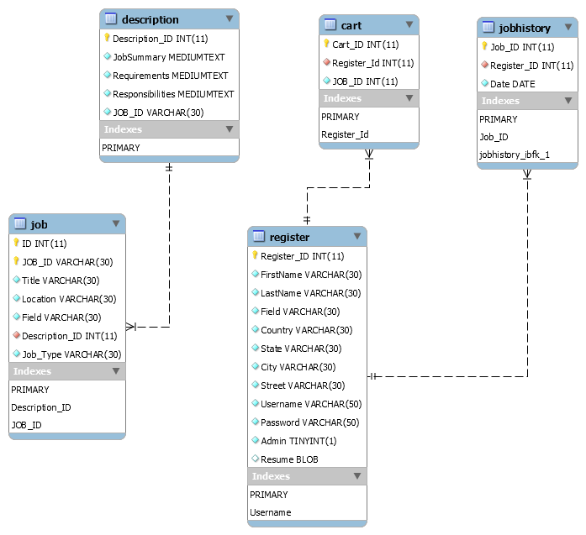

**Languages/frameworks used for implementation:**

Front end – HTML, jQuery, Bootstrap, JavaScript

Back end – PHP

Database – MySQL

Server used for testing – Apache 2.4

**Screenshots:**

**Search Page:**

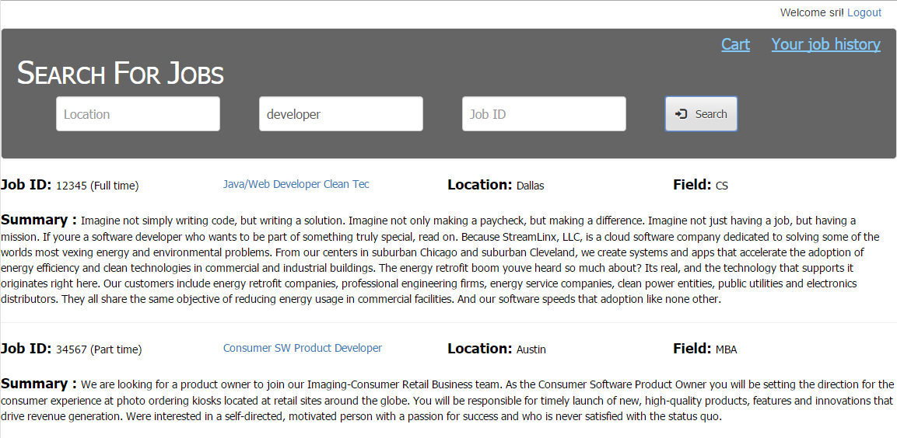

**Job Detail:**

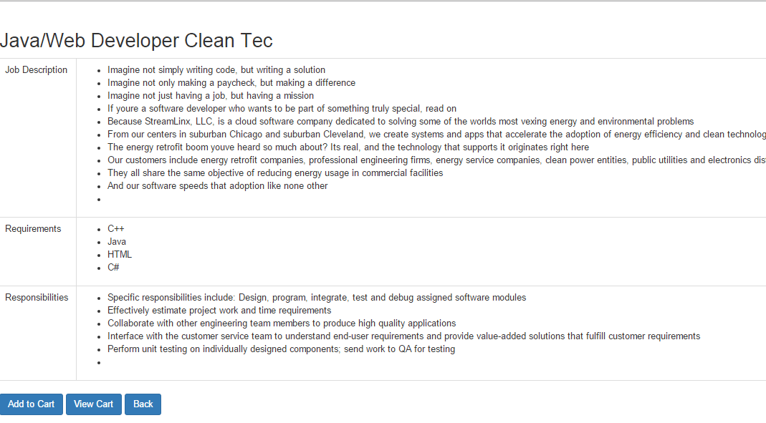

**Cart:**

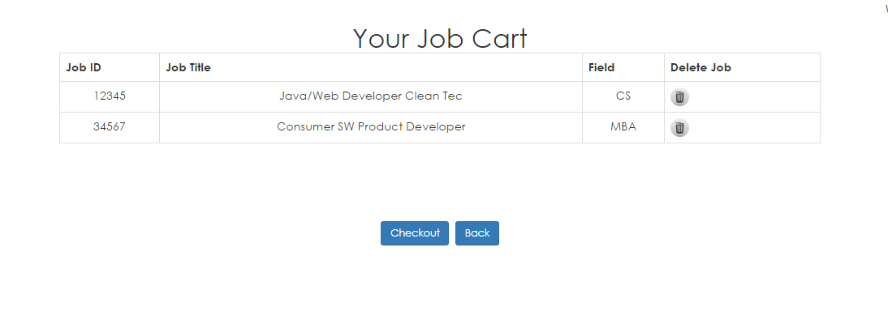

**Job History:**

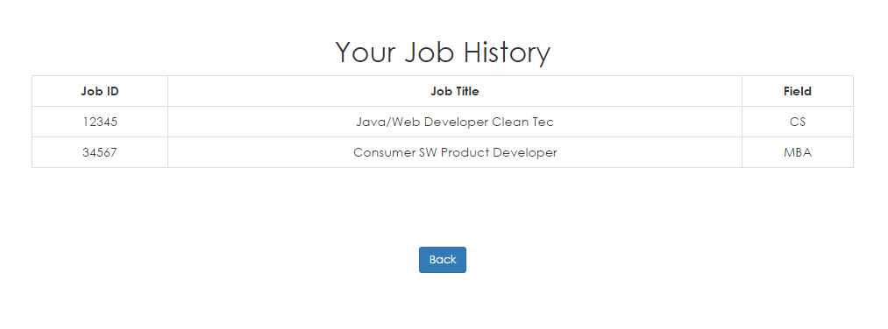

**Admin Home:**

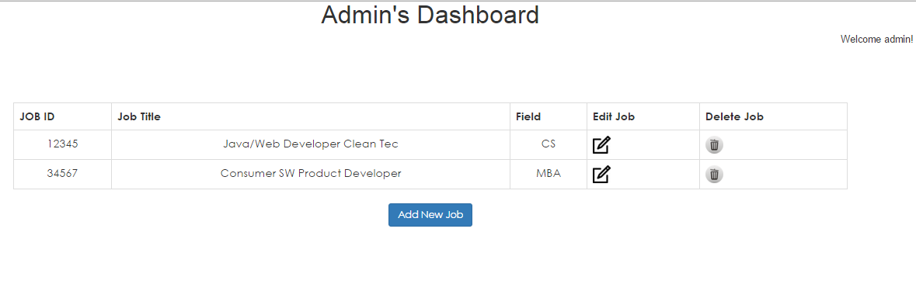

**Team Members:**

1. Bhavya Natarajan
2. Srikant Iyengar
3. Sharan Babu Paramasivam Murugesan

**Work division among team members:**

Sharan Babu Paramasivam Murugesan:

* Involved in database design
* Designed the UI for site layout (banner, CSS styling)
* Designed the UI for search page
* Implemented the back-end functionality for search module
* Involved in integrating various modules
* Testing individual modules, Integration testing

Srikant Iyengar:

* Created the Admin Module including add, edit and delete jobs to the portal.
* Implemented the view job description module for the application, allowing the user to view complete description of job.
* Implemented the Add the Job to cart functionality, allowing user to add jobs to cart.
* Implemented the view cart functionality, allowing the user to view jobs already added to cart.
* Implemented the delete from cart and Checkout functionality, allowing user to remove already added jobs from cart and to checkout jobs already present in the cart.
* Implemented the view job history page, allowing users to view jobs that he has previously applied for.
* Implemented the backend for all the above described modules.
* Implemented the UI for the Cart page, View Job description page, Job History page, Admin dashboard page, Admin add Job and Update Job page and the Checkout page.
* Involved in the integration of the modules and the design of the database.

Bhavya Natarajan: